## Server 4 (Database)

Installation of this product is supported on the following operation systems and versions:

* CentOS 7

### Roles, Features, and Packages

**Packages**

The following software packages must be installed on the operating system prior to installation of the software:

* Wget
* Zip unzip

### Configuration

SQL Server Configuration:

Virtual Cores – 2

RAM – 7.5 GB

Authentication

SSH/FTP

Server Network Configuration

TCP/IP should be enabled

Firewall allow port – TCP: 1521

### Software Installations

#### Prerequisites

Update and upgrade Linux default packages

#### Installation Steps

**Step1 – Configure a suitable swap space:**

* Check if your machine already has a swap space configured

[root@centos7 ~]# swapon --show

* If no output seen, configure a suitable swap space:

[root@centos7 ~]# dd if=/dev/zero of=/swapfile bs=1K count=1M

[root@centos7 ~]# chmod 600 /swapfile

[root@centos7 ~]# mkswap /swapfile

[root@centos7 ~]# swapon /swapfile

[root@centos7 ~]# vi /etc/fstab

/swapfile swap swap defaults 0 0 **<- Add this to /etc/fstab**

[root@centos7 ~]# swapon –show

**Step 2 - Downloading Oracle 12C release 2**

* Initiate the download using your computer’s browser, pausing the download and copying the download URL, which contains the authentication token in it.

[root@centos7 ~]# *curl download_url > file_name.zip*

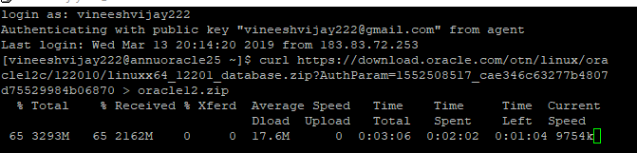

**Step 3- Add Groups and Users**

[root@centos7 ~]# groupadd oinstall

[root@centos7 ~]# groupadd dba

[root@centos7 ~]# useradd -g oinstall -G dba oracle

[root@centos7 ~]# passwd oracle

**Edit Kernel Parameters**

Add the following kernel parameters to the /etc/sysctl.conf

[root@centos7 ~]# vi /etc/sysctl.conf

Add following parameters in the file: (Make sure no ‘#’ are pre-fixed before these parameters)

fs.file-max = 6815744

kernel.sem = 250 32000 100 128

kernel.shmmni = 4096

kernel.shmall = 1073741824

kernel.shmmax = 4398046511104

net.core.rmem_default = 262144

net.core.rmem_max = 4194304

net.core.wmem_default = 262144

net.core.wmem_max = 1048576

fs.aio-max-nr = 1048576

net.ipv4.ip_local_port_range = 9000 65500

[root@centos7 ~]# sysctl -p **<- apply changes**

**Step 4- Edit Limits file**

[root@centos7 ~]# vi etc/security/limits.conf

**ADD at EOF ->**

* soft stack 10240

oracle soft nofile 1024

oracle hard nofile 65536

oracle soft nproc 2047

oracle hard nproc 16384

oracle soft stack 10240

oracle hard stack 32768

**Step 5: Install dependencies**

[root@centos7 ~]# yum install -y binutils.x86_64 compat-libcap1.x86_64 gcc.x86_64 gcc-c++.x86_64 glibc.i686 glibc.x86_64 \

glibc-devel.i686 glibc-devel.x86_64 ksh compat-libstdc++-33 libaio.i686 libaio.x86_64 libaio-devel.i686 libaio-devel.x86_64 \

libgcc.i686 libgcc.x86_64 libstdc++.i686 libstdc++.x86_64 libstdc++-devel.i686 libstdc++-devel.x86_64 libXi.i686 libXi.x86_64 \

libXtst.i686 libXtst.x86_64 make.x86_64 sysstat.x86_64

**Step 6: Unzipping the downloaded file**

[root@centos7 ~]# unzip *file_name.zip –d /oracle/*

This will unzip the file in a directory /oracle, which is placed at the root.

Run *yum install unzip,* if unzip is unavailable, then re-try

**Step 7: Changing the ownership of the file /oracle to the user created in Step2**

[root@centos7 ~]# chown -R oracle:oinstall /oracle

[root@centos7 ~]# chmod -R 775 /oracle

[root@centos7 ~]# chmod g+s /oracle

**Step 8:**  **Also install the** "X Window System" **package group, because the Oracle installation requires GUI**

[root@centos7 ~]# yum groupinstall -y "X Window System"

[root@centos7 ~]# yum install xorg-x11-apps.x86_64 <- To test the UI tool

Disconnect from the present session, we will reconnect with a fresh connection with xming associated with it

**Step 9: (To be done on your personal/local machines) Download Xming in your local/personal machine and keep it running.**

Xming is also available in the software centre, install and keep it running in your local machine.

Alternatively, Download from this link: *https://sourceforge.net/projects/xming/*

**Step 10: Open up putty to associate Xming (Make sure Xming is running in the background)**

**Type in the IP Address of the VM**

**AND**

**A**: Open putty, under ‘Auth’, define the proper private key to connect

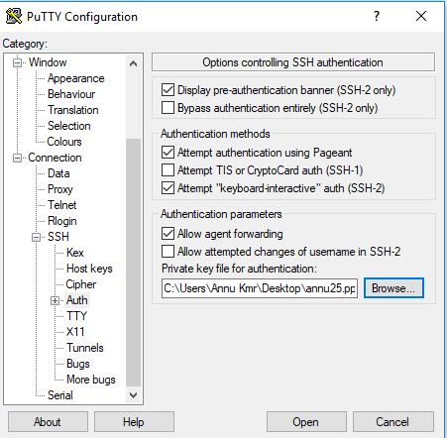

**B:** Under **X11** make sure to check “*Enable X11 forwarding”*

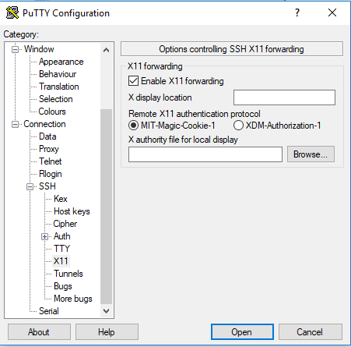

Also select **MIT-Magic-Cookie-**1 as the authentication protocol

Open up the connection now.

**Step 11: Run xclock to verify if you can see a Graphics clock**

[username@centos7 ~]# xclock

A small clock should pop up in your local machine, as shown

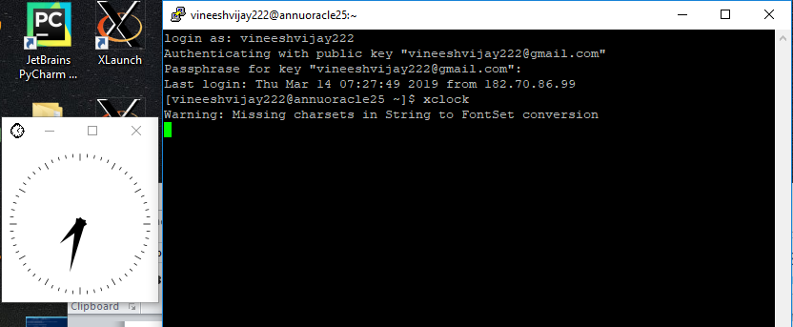

If you can see the clock, you are good to proceed with the oracle installation.

**Step 12: Switch to user oracle, (created in step2)**

[username@centos7 ~]# su – oracle

Give the password for it when prompted

Run the installer file previously unzipped in oracle (Absolute path may change, but make sure you run the executable “runInstaller”)

[oracle@centos7 ~]$ /oracle/database/runInstaller

Starting Oracle Universal Installer...

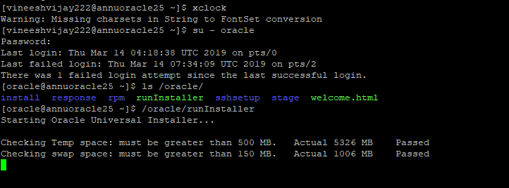

After performing few checks, you’ll see an Oracle12C installation screen pop up,

1. This is an optional step, feed in your email ID if willing to receive security updates, Click next.

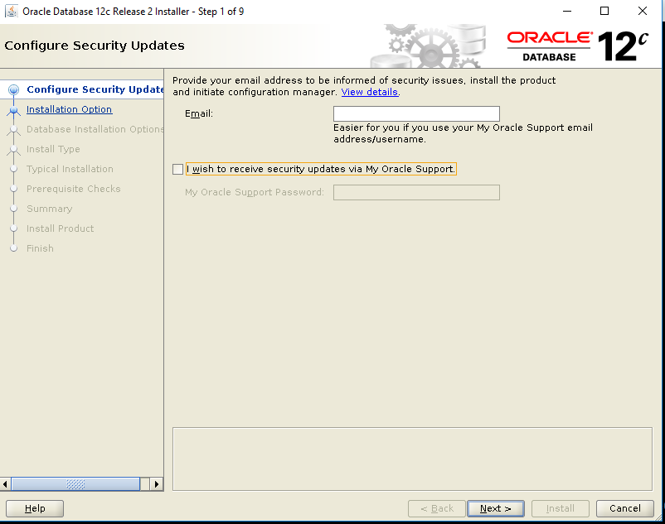

1. Select Create and Configure a Database.

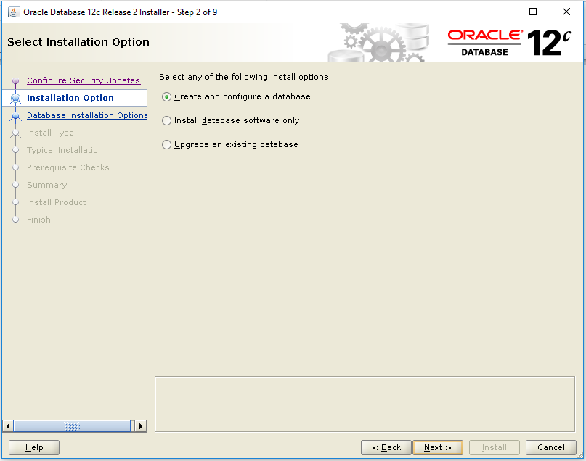

1. Select option Server class.

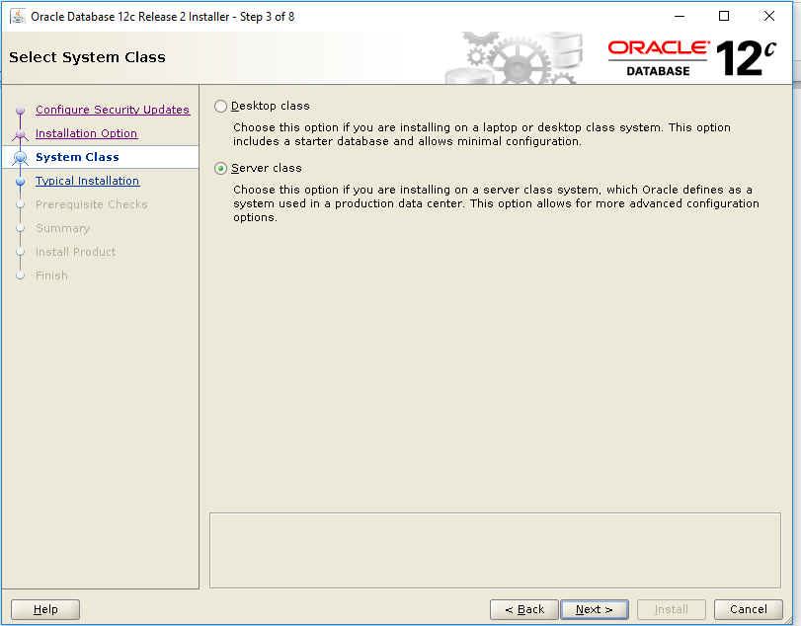

1. Select Option single Instance database installation.

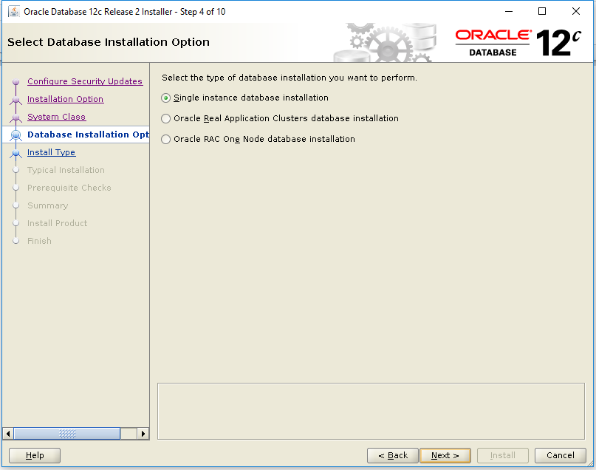

1. Select option Advanced install.

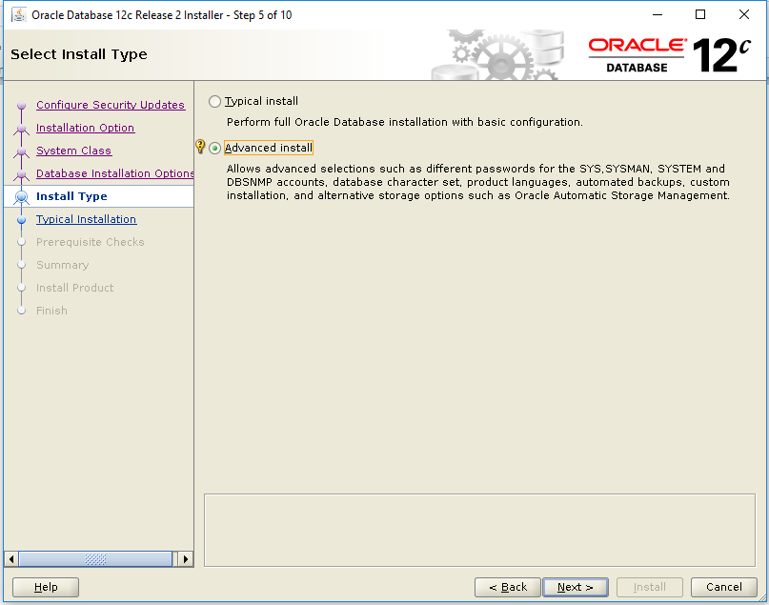

1. Select option Enterprise Edition.

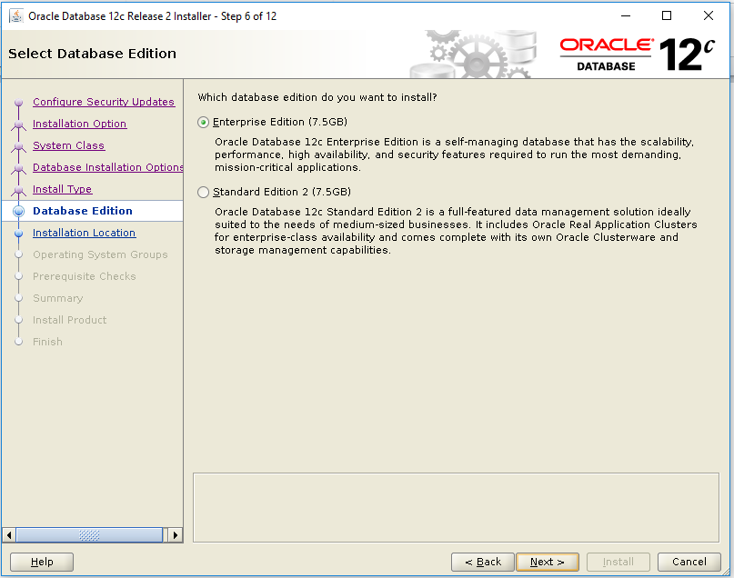

### Feed in the path for Oracle base and Software Location.

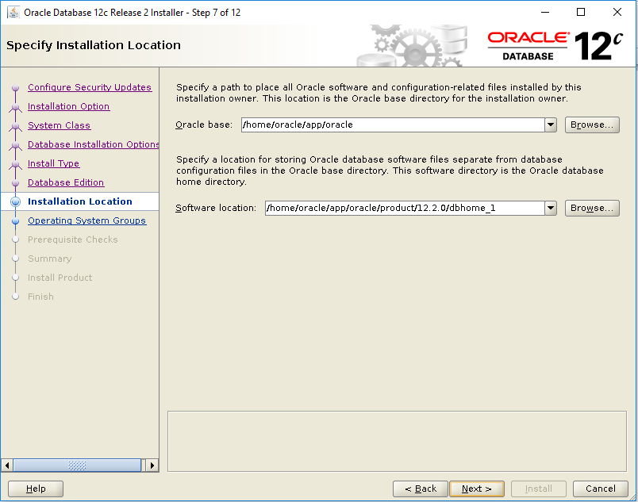

1. Specify the path for inventory directory.

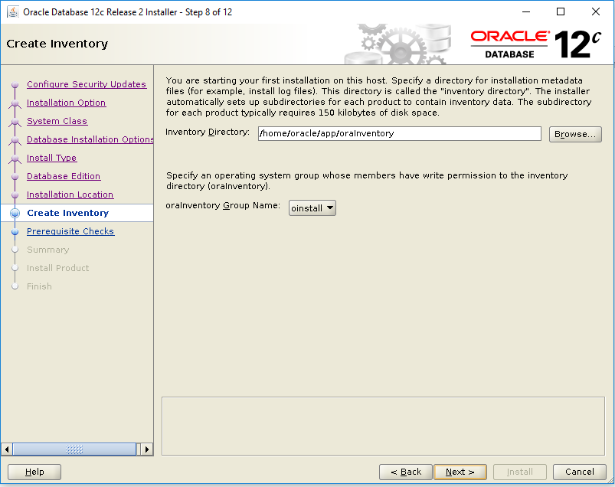

1. Select option General Purpose.

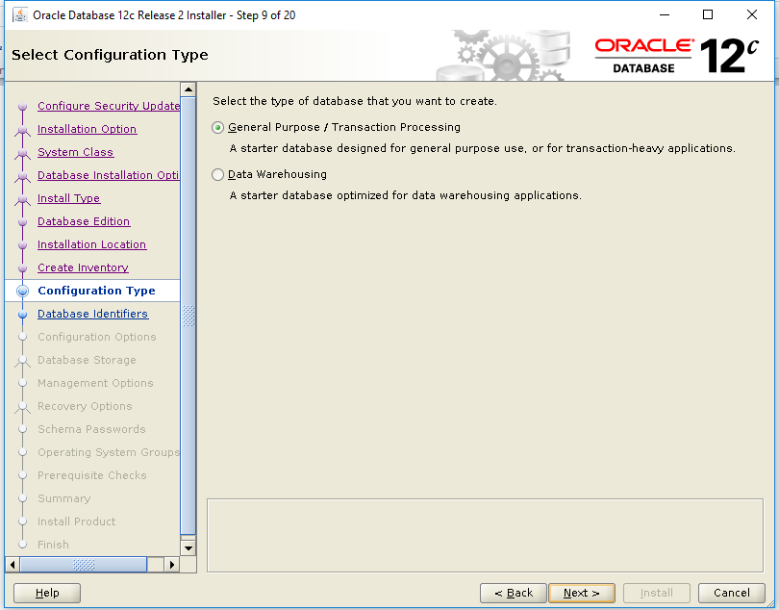

1. Feed in Global Database name and SID.

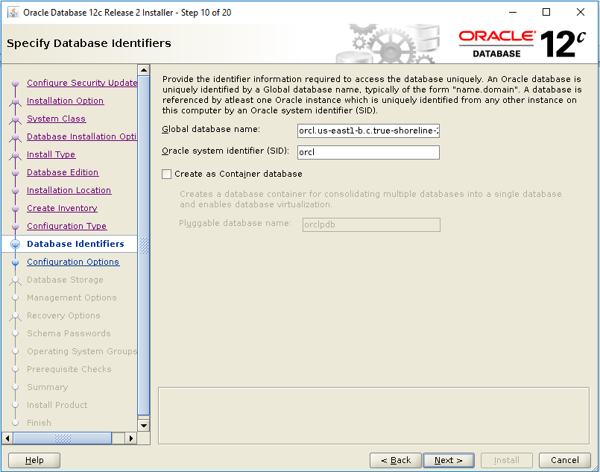

1. 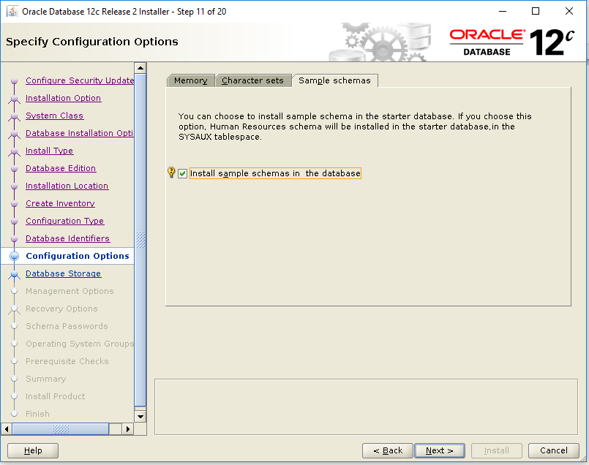Select Install Sample Schemas if you want the sample schema.
2. Select option File System and feed in the path for it.

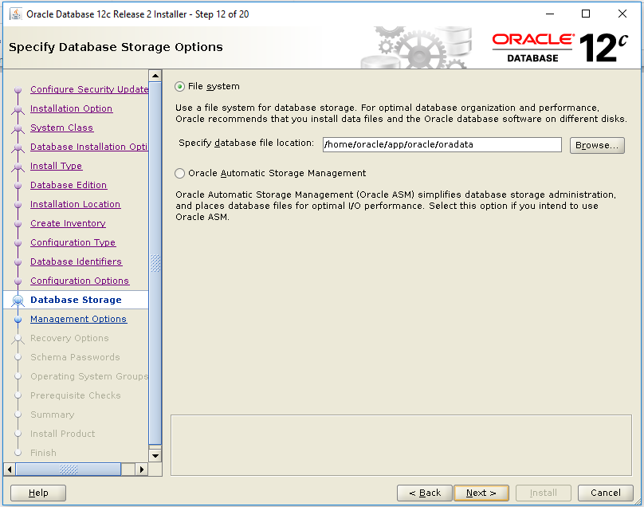

1. Optional, can opt to Register for EM Cloud Manager

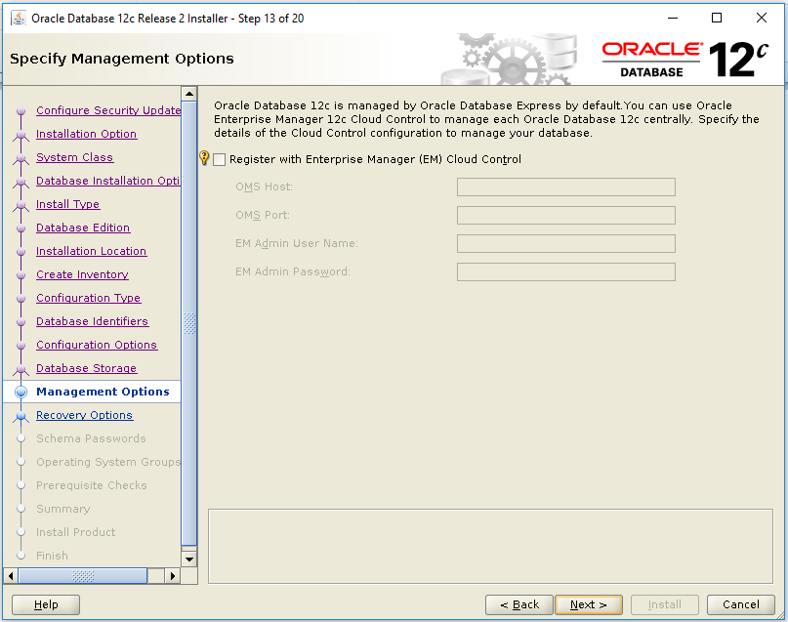

1. Optional, can opt to enable recovery and specify a path for Recovery

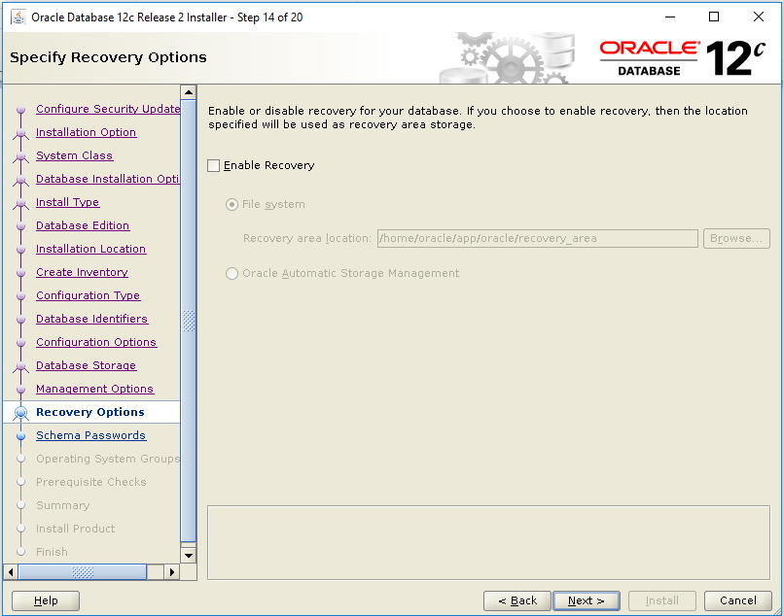

15

1. Here, you can choose to specify different/same passwords for sys and system

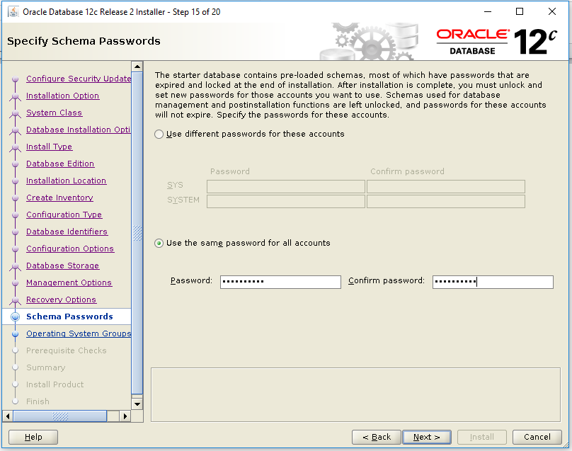

1. Select dba in options.

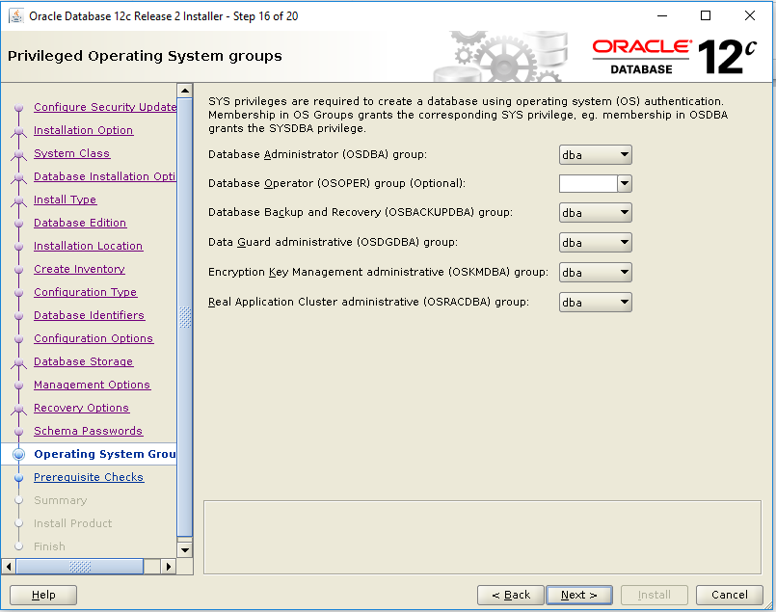

1. This performs prerequisite checks before actually installing

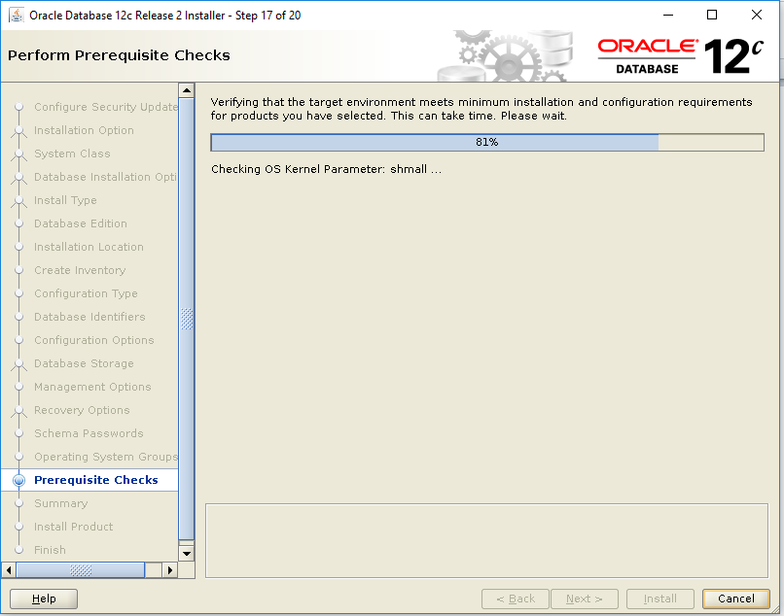

During checks if there are any discrepancies, you can go back to the new shell as root and fix them.

(Do not close the oracle installation screen)

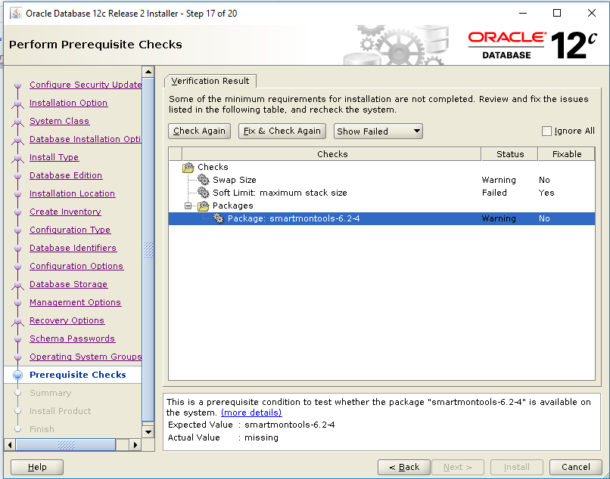

For smartmontools-6.2-4

[root@centos7 ~]# yum install smartmontools

You can choose to ignore Swap size, check on Ignore All checkbox

Once fixed the failed checks, click “Fix & Check Again”, go back to root shell and execute the script specified.

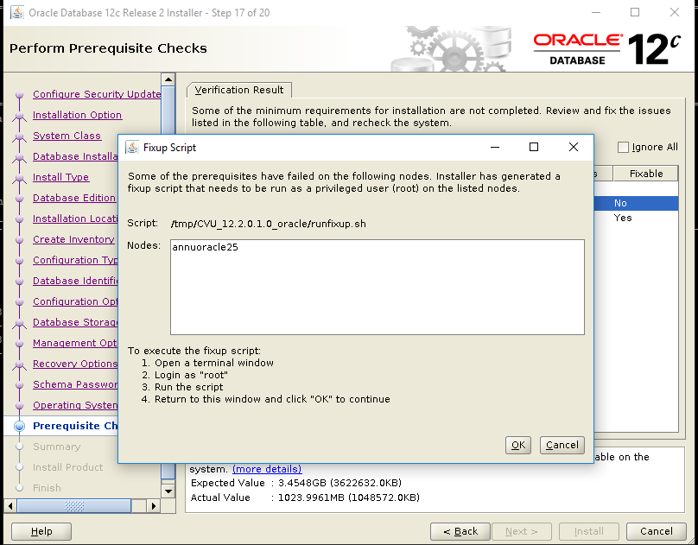

Click YES after checking “Ignore ALL”

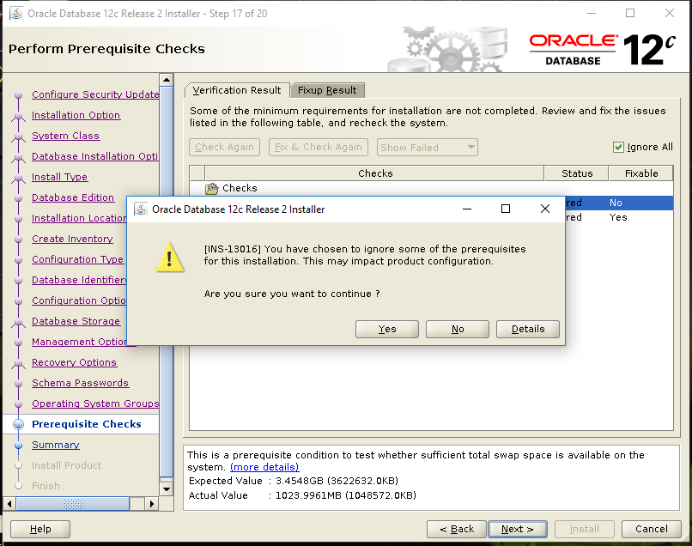

1. A summary of all configurations done so far

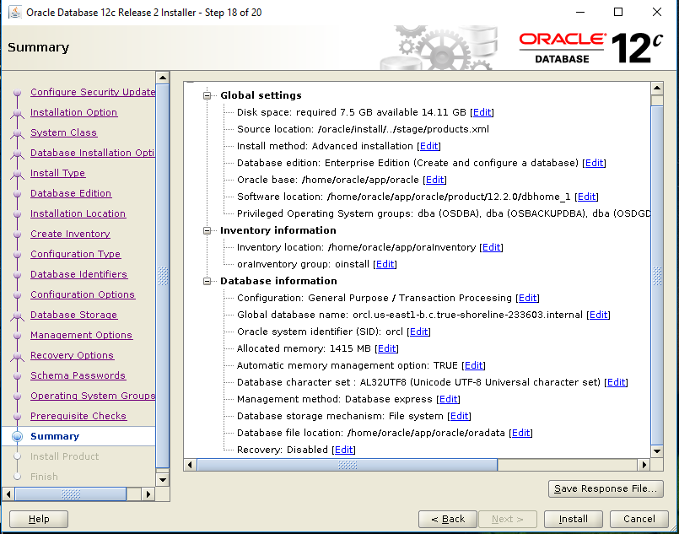

1. Product Installation.

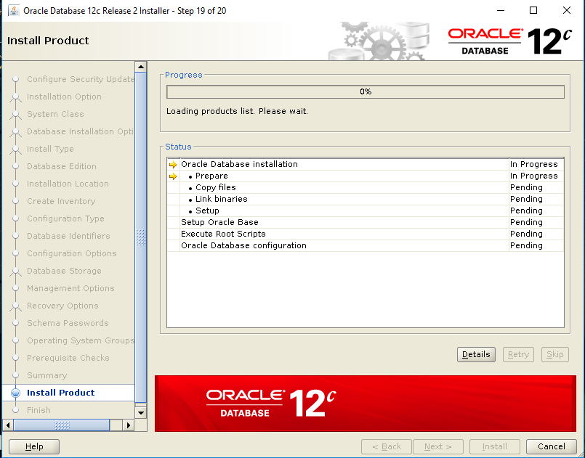

This would require you to go back to shell log in as root, and execute the scripts specified

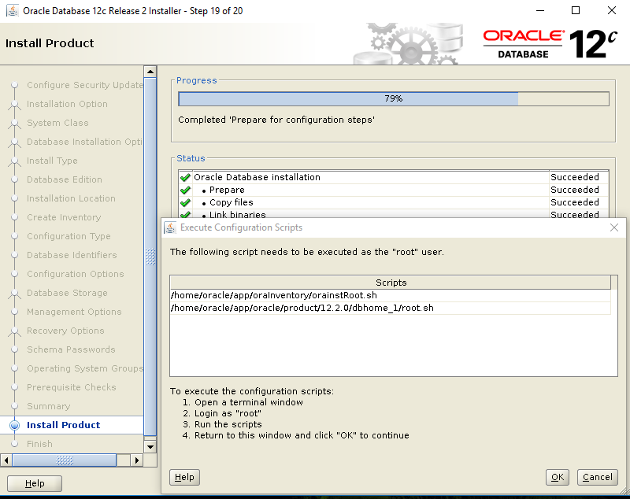

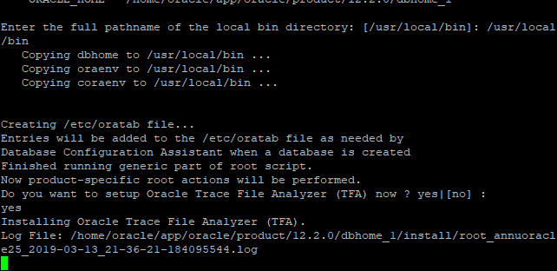

1. Finish and close.

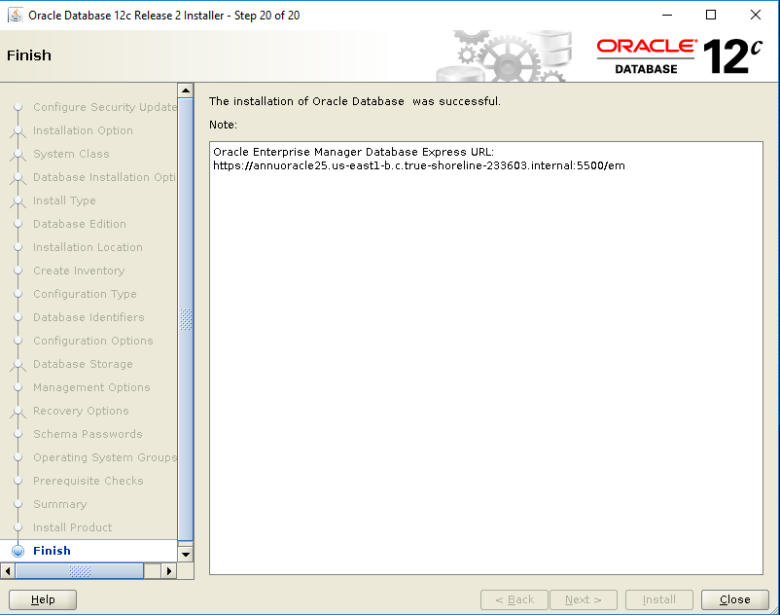

**Step 13. Post Installation.**

1. Setting environment variables

[oracle@centos7 ~]$ vi /.bash_profile

1. Adding the values, change these to your installation specific values

export TMP=/tmp

export TMPDIR=$TMP

export ORACLE_SID=orcl

export ORACLE_BASE=/home/oracle/app/oracle

export ORACLE_HOME=$ORACLE_BASE/product/12.2.0/dbhome_1

export PATH=/usr/sbin:$PATH

export PATH=$ORACLE_HOME/bin:$PATH

export LD_LIBRARY_PATH=$ORACLE_HOME/lib:/lib:/usr/lib

export CLASSPATH=$ORACLE_HOME/jlib:$ORACLE_HOME/rdbms/jlib

[oracle@centos7 ~]$ . .bash_profile

1. **Connecting to Oracle12c**

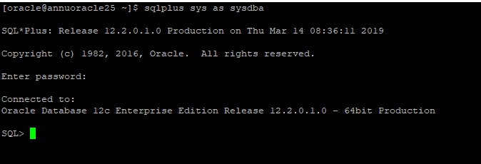

1. **To Connect remotely,**

* Start Listener

[oracle@annuoracle25 ~]$ lsnrctl start

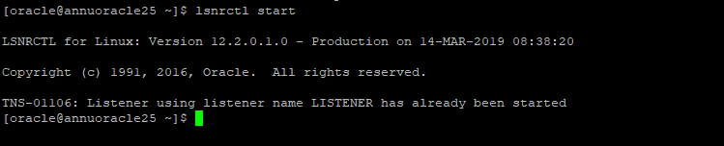

Also Check if Oracle SID is running *tnsping orcl*

[oracle@annuoracle25 ~]$ tnsping orcl

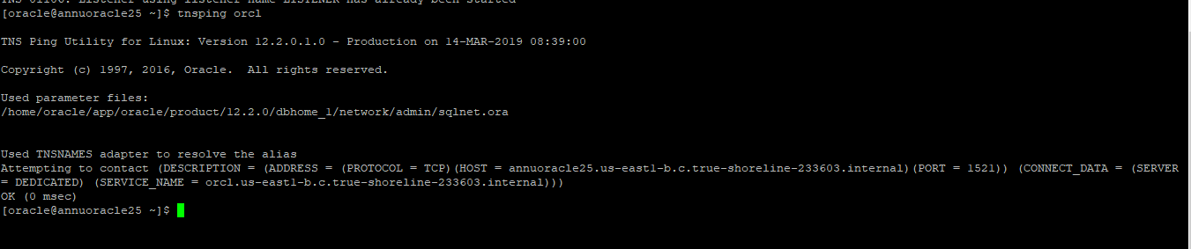

1. **Using Sql Developer to connect**

You might have to add a firewall rule to allow connections through port 1521 and other related ports

Once ports are open, you can test the connection once all values are fed in.

